Title: Fertilizer Recommendation System Using Machine Learning
Done by : Pritesh Ram Keshri Project Number : 16, Submission Date: 20th July 2025
Overview:

This project implements a Fertilizer Recommendation System using machine learning techniques. Based on input soil parameters and environmental conditions, the system recommends the most suitable type of fertilizer. The goal is to assist farmers in selecting fertilizers that optimize crop yield while maintaining soil health.
The system includes separate modules for training the model, making predictions, defining model architecture, and utility functions. It is structured for scalability, modularity, and integration into agricultural tech platforms.

Libraries used:

pandas, numpy – Data manipulation and numerical operations
scikit-learn – Model building and evaluation
joblib – Saving and loading trained models
argparse, os, json – Command-line interface and configuration management

Dataset Details:

Source: Custom/Simulated dataset - https://www.kaggle.com/code/jshndeep/fertilizer-recommendation-system
Format: CSV file (e.g., fertilizer_data.csv)
Features:
- Soil nutrients: Nitrogen (N), Phosphorus (P), Potassium (K)
- Environmental parameters: Temperature, Humidity, Moisture
- Soil Type and Crop Type (Categorical)
Target: Fertilizer Name (e.g., Urea, DAP, Potash)

APIs Integrated:

No external APIs were integrated. All training and prediction processes are executed locally through modular Python scripts
Source code 1: App Configuration and Styling
File Name : Importing libraries, train.py
import pandas as pd
import numpy as np
from sklearn.ensemble import RandomForestClassifier
from sklearn.model_selection import train_test_split
from sklearn.preprocessing import LabelEncoder
import joblib

# Load dataset
df = pd.read_csv("fertilizer_data.csv")

# Encode categorical features
le_crop = LabelEncoder()
le_soil = LabelEncoder()
le_fert = LabelEncoder()

df['Crop Type'] = le_crop.fit_transform(df['Crop Type'])
df['Soil Type'] = le_soil.fit_transform(df['Soil Type'])
df['Fertilizer Name'] = le_fert.fit_transform(df['Fertilizer Name'])

# Feature and target
X = df.drop("Fertilizer Name", axis=1)
y = df["Fertilizer Name"]

# Split data
X_train, X_test, y_train, y_test = train_test_split(X, y, test_size=0.2, random_state=42)

# Train model
model = RandomForestClassifier()
model.fit(X_train, y_train)

# Save model and encoders
joblib.dump(model, "fertilizer_model.pkl")
joblib.dump(le_crop, "crop_encoder.pkl")
joblib.dump(le_soil, "soil_encoder.pkl")
joblib.dump(le_fert, "fertilizer_encoder.pkl")

Source code 2: model.py

import joblib

class FertilizerModel:
def __init__(self):
self.model = joblib.load("fertilizer_model.pkl")
self.crop_encoder = joblib.load("crop_encoder.pkl")
self.soil_encoder = joblib.load("soil_encoder.pkl")
self.fertilizer_decoder = joblib.load("fertilizer_encoder.pkl")

def predict(self, features):
pred = self.model.predict([features])
return self.fertilizer_decoder.inverse_transform(pred)[0]

Source code 3: predict.py

import argparse
from model import FertilizerModel
import json

# CLI input
parser = argparse.ArgumentParser()
parser.add_argument("--input", type=str, required=True, help="JSON input file")
args = parser.parse_args()

# Load input
with open(args.input, "r") as f:
data = json.load(f)

features = [
data["N"],
data["P"],
data["K"],
data["temperature"],
data["humidity"],
data["moisture"],
data["soil_type_encoded"],
data["crop_type_encoded"]
]

# Predict
model = FertilizerModel()
fertilizer = model.predict(features)
print("Recommended Fertilizer:", fertilizer)
Source Code 4: utils.py

from sklearn.preprocessing import LabelEncoder

def encode_categories(df):
le_crop = LabelEncoder()
le_soil = LabelEncoder()

df['Crop Type'] = le_crop.fit_transform(df['Crop Type'])
df['Soil Type'] = le_soil.fit_transform(df['Soil Type'])

return df, le_crop, le_soil

def save_encoders(le_crop, le_soil):
import joblib
joblib.dump(le_crop, "crop_encoder.pkl")
joblib.dump(le_soil, "soil_encoder.pkl")

Output screenshots:

Here , are the snapshots of my working project.

1. Streamlit Web UI Output - This is the starting interface of my project.
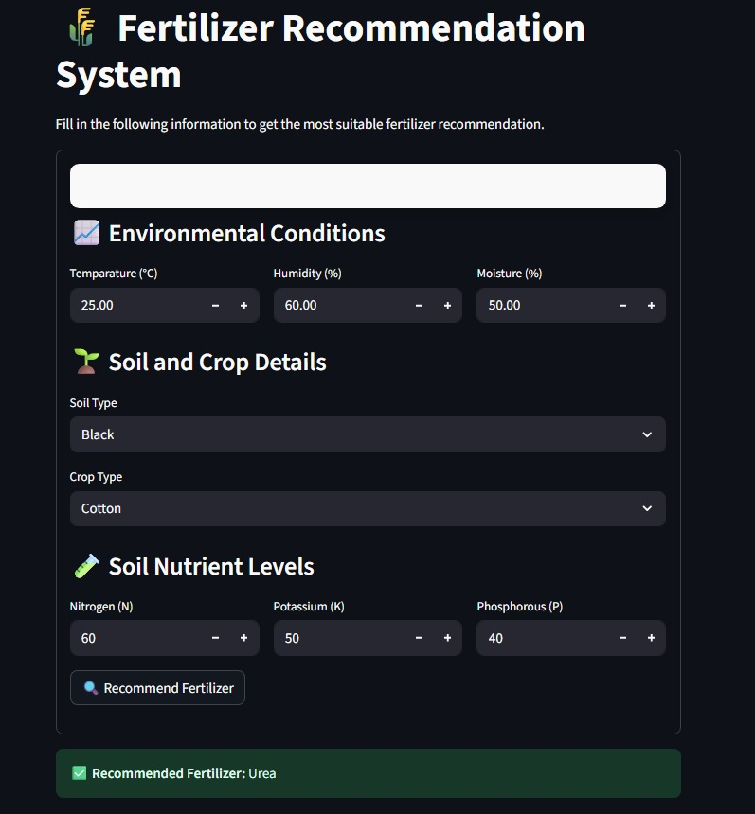

2. Prediction Result: Fertilizer recommendation shown in terminal.
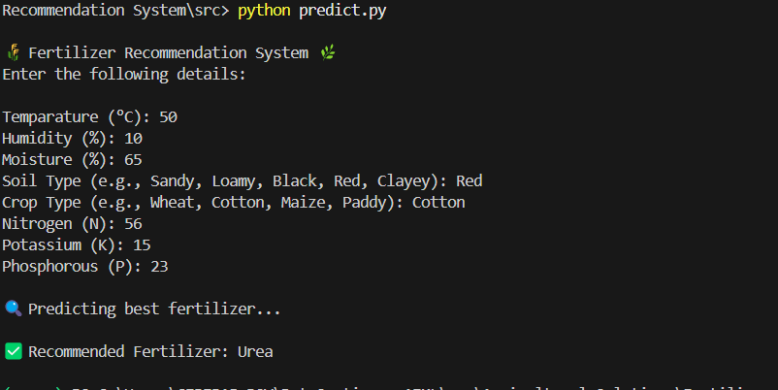

3. Logs or Visuals: Correlation Heatmap
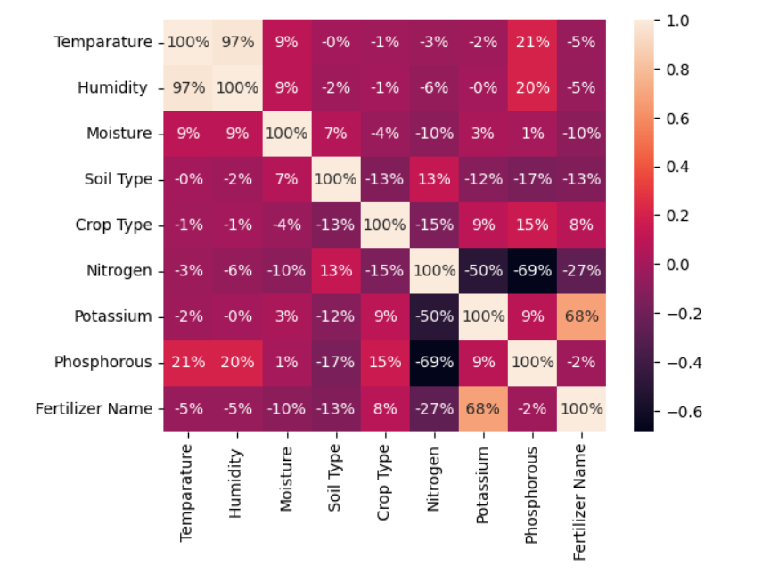

What you learned:

Through this project, I gained hands-on experience with:

- Developing an end-to-end recommendation system using ML
- Data encoding and transformation for classification tasks
- Model evaluation and result interpretation
- Deploying a model using Python CLI structure

What the Skills you gained:

- ML classification with scikit-learn
- Feature engineering and label encoding
- Model serialization and usage in prediction
- Modular project structuring with reusable components

Real Time Applications:

- Fertilizer advisory for farmers using soil test kits
- Integration into agri-mobile apps or kiosks
- Precision agriculture and sustainable farming platforms
- Agri-tech solutions by NGOs and government portals

Further Enhancement Suggestions:

- Add weather API for real-time context
- Integrate crop stage or season for better accuracy
- Deploy as a web/mobile app for accessibility
- Include multi-language support for farmer usability

